Enterprise CA
# Source: AI Source: Provided by: [Data Path: Persons Table -> ID Column: 1, Name_En Column: Motasem Essam] -> From: [ChatGPT] on [1/18/2026]
An Enterprise/Internal CA is a Certificate Authority that is set up and managed within an organization (rather than being a public/global CA). It issues certificates for internal use only, such as company servers, devices, or employees, and is trusted only within the organization’s network.
Think of it as a private notary for your company.

🔑 Key Features
# Source: AI Source: Provided by: [Data Path: Persons Table -> ID Column: 1, Name_En Column: Motasem Essam] -> From: [ChatGPT] on [1/18/2026]
- Internal trust
  - Certificates issued by an internal CA are trusted only on devices configured to trust that CA
  - Not automatically trusted by public browsers or the internet
- Controlled issuance
  - The organization decides who gets certificates and for what purpose
  - Can enforce strict policies and expiration rules
- Supports various use cases
  - Secure internal websites (intranet)
  - VPN and Wi-Fi authentication
  - Email encryption/signing (S/MIME)
  - Code signing for internal applications
  - Device authentication in corporate networks

📍 Examples
# Source: AI Source: Provided by: [Data Path: Persons Table -> ID Column: 1, Name_En Column: Motasem Essam] -> From: [ChatGPT] on [1/18/2026]
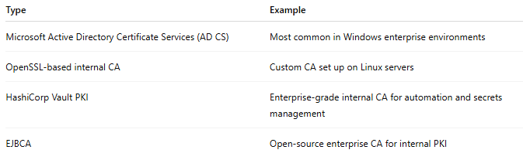
Type | Example
Microsoft Active Directory Certificate Services (AD CS) | Most common in Windows enterprise environments
OpenSSL-based internal CA | Custom CA set up on Linux servers
HashiCorp Vault PKI | Enterprise-grade internal CA for automation and secrets management
EJBCA | Open-source enterprise CA for internal PKI

✅ Advantages
# Source: AI Source: Provided by: [Data Path: Persons Table -> ID Column: 1, Name_En Column: Motasem Essam] -> From: [ChatGPT] on [1/18/2026]
- Full control over certificate issuance and revocation
- Can enforce strict internal policies (short lifetimes, roles, permissions)
- Cheaper than purchasing certificates from global CAs for internal systems
- Supports automation for large-scale deployments

⚠️ Disadvantages
# Source: AI Source: Provided by: [Data Path: Persons Table -> ID Column: 1, Name_En Column: Motasem Essam] -> From: [ChatGPT] on [1/18/2026]
- Not trusted outside the organization
- Requires management of trust on all devices (root certificates must be installed)
- Needs careful security of the CA server and private keys

🔒 Best practices
# Source: AI Source: Provided by: [Data Path: Persons Table -> ID Column: 1, Name_En Column: Motasem Essam] -> From: [ChatGPT] on [1/18/2026]
- Secure the CA server (offline if possible for root CA)
- Use strong cryptographic keys (ED25519, RSA 3072+)
- Regularly rotate and revoke certificates
- Keep detailed logs of certificate issuance
- Automate trust distribution within the organization

🧠 Authentication factor
# Source: AI Source: Provided by: [Data Path: Persons Table -> ID Column: 1, Name_En Column: Motasem Essam] -> From: [ChatGPT] on [1/18/2026]
- Something you have → certificate/private key
- Something you know → optional passphrase for private key

Quick analogy
# Source: AI Source: Provided by: [Data Path: Persons Table -> ID Column: 1, Name_En Column: Motasem Essam] -> From: [ChatGPT] on [1/18/2026]
- Enterprise CA = Company’s private notary office
- Certificate = Internal notarized document for employee, server, or device
- Trust = Only works inside the company network

